**do-while Script**

**Script to run for a number of times**

#!/bin/bash

c=1

while [ $c -le 5 ]

do

echo "Welcone $c times"

(( c++ ))

done

vi dowhilerunnumtimes.bash

write a script as above

save it

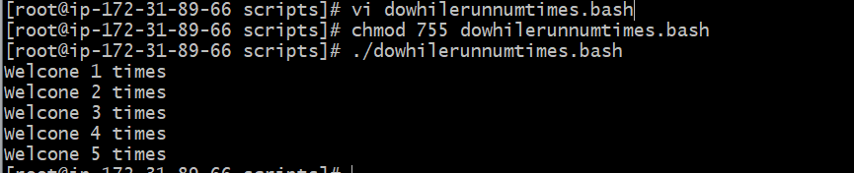

2. **Script to run for a number of seconds**

#!/bin/bash

count=0

num=10

while [ $count -lt 10 ]

do

echo

echo $num seconds left to stop this process $1

echo

sleep 1

num=`expr $num - 1`

count=`expr $count + 1`

done

echo

echo $1 process is stopped!!!

echo

vi dowhilerunnumseconds.bash

write a script as above

save it

execute it

